**SYDNEY WESTERN CITY PLANNING PANEL ASSESSMENT REPORT**

|  |  |
| --- | --- |
| Panel Number: | PPSSWC-331. |
| Application Number: | 2023/263/1. |
| Local Government Area: | Camden. |
| Development: | Construction of Stage 3B of the Oran Park Podium involving the construction of a six-storey hotel building with ground floor retail tenancies, basement car parking, streetscape embellishment along Podium Way and other associated works. |
| Capital Investment Value: | $55,918,111. |
| Site Address(es): | 351 Oran Park Drive, Oran Park. |
| Applicant: | Greenfields Development Company No.2 Pty Ltd. |
| Owner(s): | Perich Property Pty Ltd. |
| Date of Lodgement: | 10 May 2023. |
| Number of Submissions: | Nil. |
| Number of Unique Objections: | Not applicable. |
| Classification: | Regionally significant. |
| Recommendation: | Approve with conditions. |
| Regionally Significant Development Criteria (Schedule 6 of State Environmental Planning Policy (Planning Systems) 2021): | General development capital investment value >$30 million. |
| List of All Relevant Section 4.15(1)(a) Matters: | * State Environmental Planning Policy (Planning Systems) 2021. * State Environmental Planning Policy (Precincts - Western Parkland City) 2021. * State Environmental Planning Policy (Resilience and Hazards) 2021. * State Environmental Planning Policy (Industry and Employment) 2021. * State Environmental Planning Policy (Biodiversity and Conservation) 2021. * Camden Development Control Plan 2019. * Oran Park Development Control Plan 2007. |
| List all Documents Submitted with this Report for the Panel’s Consideration: | * Assessment report. * State Environmental Planning Policy (Precincts - Western Parkland City) 2021 assessment table. * State Environmental Planning Policy (Industry and Employment) 2021 assessment table. * Camden Development Control Plan 2019 assessment table. * Oran Park Development Control Plan 2007 assessment table. * Applicant’s 4.6 written request seeking to justify the contravention of a development standard. * Recommended conditions. * Proposed plans. |
| Development Standard Contravention Request(s): | Section 4.3 Height of buildings |
| Summary of Key Submission Issues: | No written submissions were received during the assessment of this development application. |
| Report Prepared By: | Jordan Soldo, Executive Planner. |
| Report Date: | 1 December 2023. |

**Summary of Section 4.15 Matters**

|  |  |
| --- | --- |
|  | **Yes** |
| Have all recommendations in relation to relevant Section 4.15 matters been summarised in the Executive Summary of the assessment report? |  |

**Legislative Sections Requiring Consent Authority Satisfaction**

|  |  |
| --- | --- |
|  | **Yes** |
| Have relevant sections in all applicable environmental planning instruments where the consent authority must be satisfied about a particular matter been listed and relevant recommendations summarised in the Executive Summary of the assessment report? |  |

**Development Standard Contraventions**

|  |  |  |
| --- | --- | --- |
|  | **Yes** | **N/A** |
| If a written request for a contravention to a development standard has been received, has it been attached to the assessment report? |  |  |

**Special Infrastructure Contributions**

|  |  |  |
| --- | --- | --- |
|  | **Yes** | **No** |
| Does the application require Special Infrastructure Contributions? |  |  |

**Conditions**

|  |  |
| --- | --- |
|  | **Yes** |
| Have draft conditions been provided to the applicant for comment? |  |

Purpose of Report

The purpose of this report is to seek the Sydney Western City Planning Panel’s (the Panel’s) determination of a development application (DA) for Stage 3B of the Oran Park Podium at 351 Oran Park Drive, Oran Park.

The Panel is the consent authority for this DA as the capital investment value (CIV) of the development is $55,918,111. This exceeds the CIV threshold of $30 million for Council to determine the DA pursuant to Schedule 7 of State Environmental Planning Policy (Planning Systems) 2021.

Summary of Recommendation

That the Panel determine DA/2023/45/1 for Stage 3B of the Oran Park Podium pursuant to Section 4.16 of the *Environmental Planning and Assessment Act, 1979* by granting consent subject to the conditions attached to this report.

Executive Summary

Council is in receipt of a DA for Stage 3B of the Oran Park Podium at 351 Oran Park Drive, Oran Park.

The DA has been assessed against the *Environmental Planning and Assessment Act, 1979*, the *Environmental Planning and Assessment Regulation, 2021*, relevant environmental planning instruments, development control plans and policies.

A summary of the assessment of all relevant environmental planning instruments is provided below with a detailed assessment provided later in the report.

|  |  |
| --- | --- |
| State Environmental Planning Policy (Planning Systems) 2021. | The Panel is the consent authority for this DA as the development has a CIV of $55,918,111. The CIV threshold for Council to determine the DA is $30 million. |
| State Environmental Planning Policy (Precincts - Western Parkland City) 2021 (Western Parkland City SEPP). | The development is permitted with consent in the applicable B2 Local Centre zone, is consistent with the zones’ objectives and acceptable in terms of the Western Parkland City SEPP’s other matters for consideration. |
| State Environmental Planning Policy (Resilience and Hazards) 2021 (Resilience and Hazards SEPP). | Council staff have considered the history of the site and note that the site has previously been signed off by a site auditor under a site audit statement that confirmed the land is suitable for the proposed land-use. Council staff are satisfied that the site is suitable for the development. |
| State Environmental Planning Policy (Industry and Employment) 2021 (Industry and Employment SEPP). | Council staff are satisfied that the signage is consistent with the Industry and Employment SEPP’s objectives in that it is compatible with the desired amenity and visual character of the area, will provide effective communication by displaying the development’s name and will be of a high quality design and finish. Council staff have also considered the Industry and Employment SEPP’s Schedule 5 assessment criteria and are satisfied that the signage is consistent with it. |
| State Environmental Planning Policy (Biodiversity and Conservation) 2021 (Biodiversity and Conservation SEPP). | The development is considered satisfactory in terms of the matters for consideration in Chapter 6 of the Biodiversity and Conservation SEPP. |

The DA was publicly exhibited for a period of 28 days in accordance with Camden Community Participation Plan 2021. The exhibition period was from 23 May to 19 June 2023 and no submissions were received.

The applicant seeks a contravention to the height of buildings development standard that applies to the site. The development standard limits buildings to a maximum height of 24m above finished ground level. The development will have a maximum height of 26.2m above finished ground level. The contravention is assessed in detail in this report and is supported by Council staff.

Based on the assessment, it is recommended that the DA be approved subject to the conditions attached to this report.

Key Planning Control Variations

|  |  |  |
| --- | --- | --- |
| **Control** | **Proposed** | **Variation** |
| 24m maximum building height. | 26.2m maximum building height. | 2.2m (9.2%). |

Aerial Photo

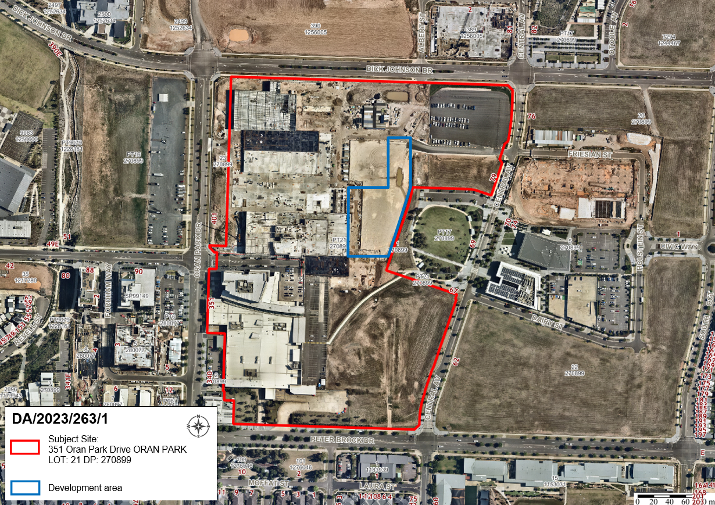

*Figure 1: Aerial photo showing the subject site outlined in red and the development footprint of the proposed development outlined in blue.*

The Site

The subject site (outlined in red above) is commonly known as 351 Oran Park Drive, Oran Park and is legally described as lot 21 in DP 270899. The subject site has an area of 12.13 hectares, has frontages to three four-lane sub arterial roads (Dick Johnson Drive, Peter Brock Drive and Oran Park Drive), and contains Stages 1 and 3A of the Oran Park Podium.

The development area of the proposed Stage 3B of the Oran Park Podium (outlined in blue above) has a footprint of approximately 0.88 hectares. The development area is bordered by the existing Stage 1 retail centre to the southwest, approved Stage 2 retail development to the south (construction yet to commence), Stage 3A retail development to the west (under construction), the Town Park to the east and future Stage 4 & 5 (not yet lodged) development area to the north.

The development site is zoned B2 Local Centre under *State Environmental Planning Policy (Sydney Region Growth Centres) 2006 – Appendix 2 Oran Park & Turner Road Precinct Plan* (the Growth Centres SEPP).

The site has been subject to earthworks as part of previous bulk earthwork approvals undertaken over the broader Town Centre and adjoining residential areas. As a result, the land is generally flat, with a slight grade from south to north to accommodate site drainage. The site is vacant and generally clear of vegetation.

Zoning Plan

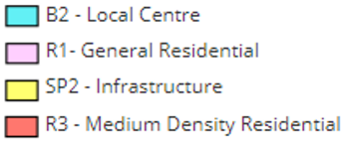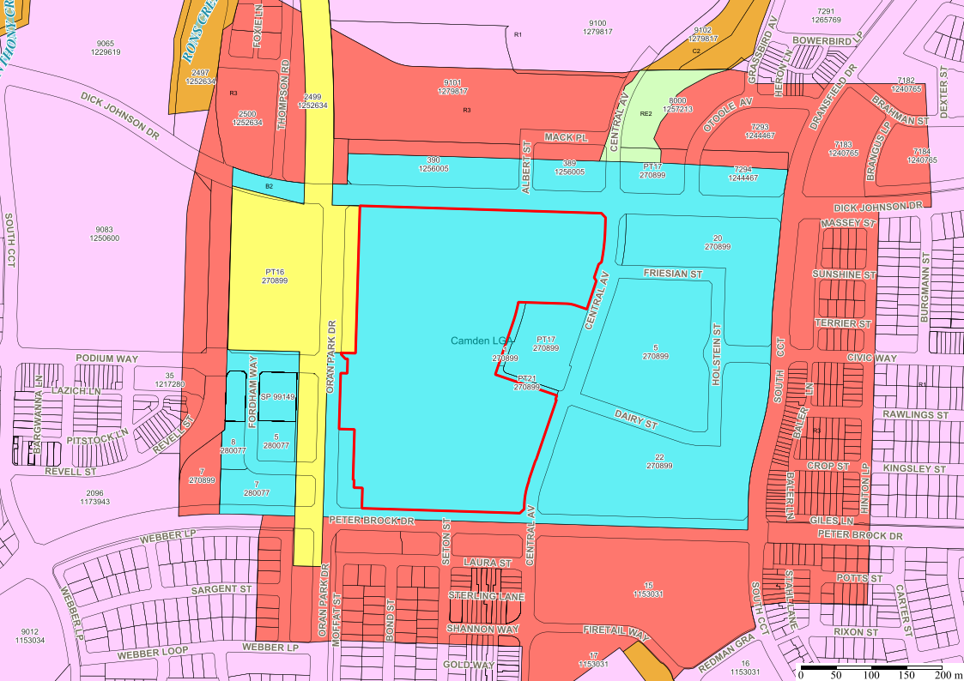

*Figure 2: Zoning map showing development footprint of the proposed development outlined in blue.*

**AREA MASTER PLAN**

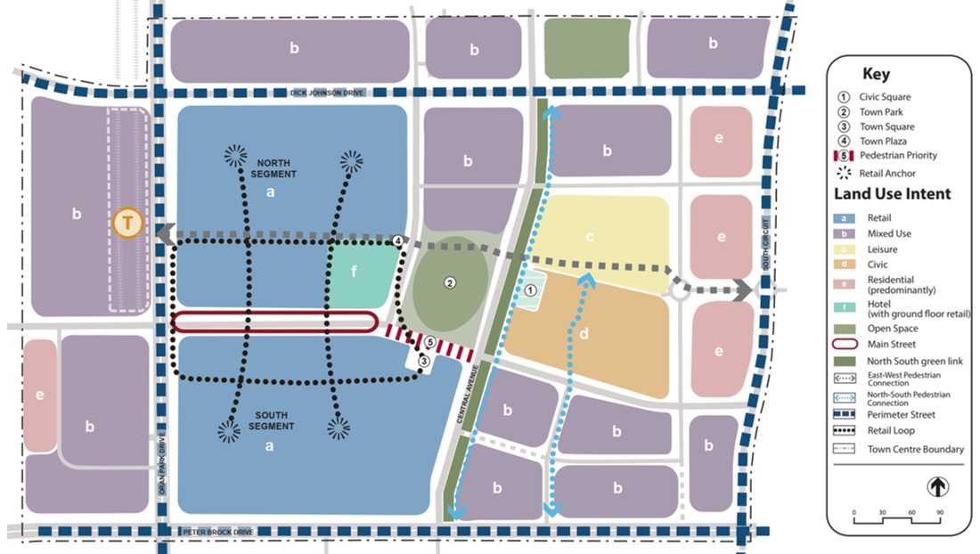

*Figure 3: Extract from Figure 50 of the Oran Park DCP showing the town centre structure with development footprint of the proposed development outlined in blue.*

**HISTORY**

The relevant development history of the site is summarised in the following table:

|  |  |
| --- | --- |
| **Date** | **Development** |
| 24 May 2012 | Approval of DA/2012/265/1 for Stage 1 of the Oran Park Podium. |
| 12 May 2020 | Approval of DA/2018/1223/1 for Stage 2 of the Oran Park Podium (construction yet to commence). |
| 23 December 2021. | Approval of DA/2021/1076/1 for Stage 3A of the Oran Park Podium (construction nearing completion). |

**THE PROPOSAL**

DA/2023/263/1 seeks approval for Stage 3B of the Oran Park Podium.

Specifically, the development involves:

* construction of a six-storey building comprising the following land uses:
* Ground floor: Six food and drink premises and three retail premises,
* Floors 1 – 5: Hotel accommodation comprising 184 rooms, dining, recreation and function facilities,

The DA seeks approval for the construction and use of the buildings as described above. The DA also seeks consent for the fit out of the hotel. The internal fit outs of the ground floor tenancies will be subject to either separate DAs or complying development certificates;

* construction of three building identification signs,
* construction of 90 basement and 32 at grade car parking spaces,
* construction of 4 motorcycle spaces and 15 bicycle spaces,
* associated site works including the construction of earthworks, drainage, services and landscaping,
* operating hours of 7.00am to 12.00midnight, seven days a week.

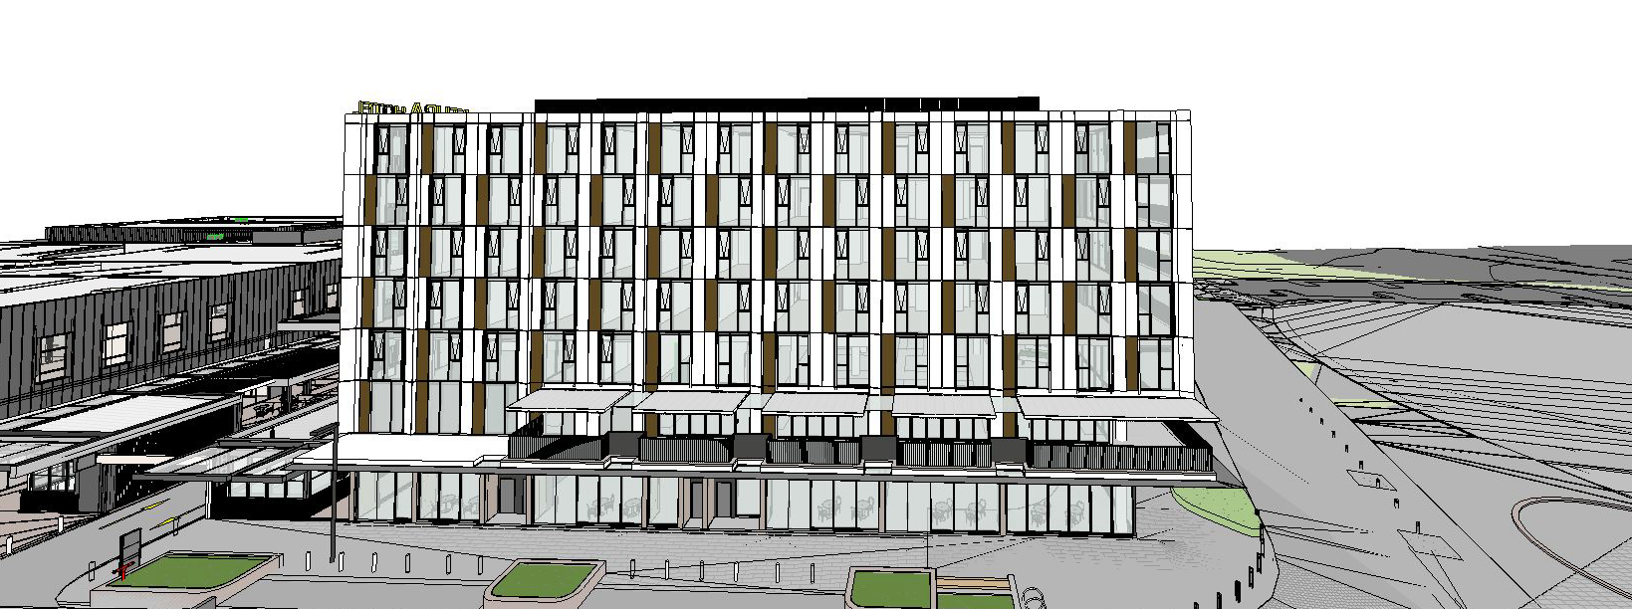

*Figure 4: 3D render showing the southern elevation.*

*Figure 5: 3D render showing the eastern elevation as viewed from Perich Park.*

**PANEL BRIEFING**

A kick-off briefing was held with the Panel on 5 June 2023. The following discussion provides an assessment of how the issues raised by the Panel at the kick-off briefing have been addressed:

1. *The presentation of the proposal to the park and the street, and particularly its engagement with the adjacent public spaces will be important not only for the success of the hotel, but also for the Oran Park town centre. It should be a key issue of the assessment.*

Officer comment:

An amendment to Part B1 of the Oran Park DCP was carried out concurrently to the assessment of this DA. Additional character statements were included for the ‘Podium Way and Retail Precinct’ and ‘Perich Park’. The statements describe the relationship between the hotel and the streetscape and park. The development is consistent with the character statements as it will provide active retail frontages and opportunities for outdoor eating overlooking Perich Park. The hotel building foyer is also differentiated from the public arcades and thoroughfares but still adds to the quality of the street, connectivity and the pedestrian experience in the precinct.

1. *That the development of the ground floor as an inviting destination for the public is therefore important. Design might consider how the First Level facilities could be available as a social destination for the area*.

Officer comment:

The proposal incorporates activated streetscape edges with retail areas along the ground level to provide an engaging and high quality façade as a continuation of the existing retail centre to the west. The first level facilities, including a restaurant, bar and swimming pool, have been designed in a way that would allow the general public to access them should the future operator wish to permit this.

1. *The plant enclosure that is proposed entirely above the maximum permitted height plane is extensive running for most of the length of the proposal. It would need to be justified, noting the potential for precedent. The Panel queried why so much plant was required.*

Officer comment:

The screening proposed on the rooftop area is solely incorporated in order to screen all of the various flues, ducts and plant/equipment required to service the hotel rooms and risers below.

The applicant has advised that there are more substantial servicing requirements associated with hotel rooms compared to residential apartments as flue and exhaust penetrations on the roof are required to be distributed across the whole floor plate due to the nature of the hotel use and number/size of rooms.

Plant and equipment have been consolidated to the central spine of the floor plate and set back from the building edge to reduce visual impacts and ensure it is not visible from pedestrian view.

The architectural plans and design proposed provide for a continuous screening treatment to appropriately screen all rooftop services utilising a consistent material and colour palette. The alternative would be to provide a series of multiple ad hoc enclosures with varying heights which would deliver an inferior presentation outcome.

**ASSESSMENT**

***Environmental Planning and Assessment Act 1979 - Section 4.15(1)***

In determining a DA, the consent authority is to take into consideration such of the following matters as are of relevance to the development the subject of the DA:

***(a)(i) the provisions of any environmental planning instrument***

The environmental planning instruments that apply to the development are:

* State Environmental Planning Policy (Planning Systems) 2021.
* State Environmental Planning Policy (Precincts - Western Parkland City) 2021.
* State Environmental Planning Policy (Resilience and Hazards) 2021.
* State Environmental Planning Policy (Industry and Employment) 2021.
* State Environmental Planning Policy (Biodiversity and Conservation) 2021.

State Environmental Planning Policy (Planning Systems) 2021 (Planning Systems SEPP)

The Planning Systems SEPP identifies development that is State significant development, infrastructure and critical infrastructure and regionally significant development.

The Panel is the consent authority for this DA as the CIV of the development is $55,918,111. The CIV threshold for Council to determine the DA is $30 million pursuant to Schedule 6 of the Planning Systems SEPP.

State Environmental Planning Policy (Precincts - Western Parkland City) 2021 (Western Parkland City SEPP)

The Western Parkland City SEPP aims to co-ordinate the release of land for residential, employment and other urban development in the North West Growth Centre, the South West Growth Centre, the Wilton Growth Area and the Greater Macarthur Growth Area.

***Site Zoning***

The site is zoned B2 Local Centre pursuant to Appendix 2, Section 2.2 of the Western Parkland City SEPP.

***Development Characterisation and Permissibility***

The development is characterised as a ‘hotel or motel accommodation’, ‘food and drink premises’ and ‘retail premises’ by the Western Parkland City SEPP.

***Permissibility***

The development is permitted with consent in the B2 Local Centre zone pursuant to the land use table in Appendix 2 of the Western Parkland City SEPP.

***Planning Controls***

An assessment table in which the development is considered against the Western Parkland City SEPP’s planning controls is provided as an attachment to this report.

***Proposed Contravention – Clause 4.3 Height of buildings***

The applicant seeks a contravention to the height of buildings development standard that applies to the site. The development standard limits buildings to a maximum height of 24m above finished ground level. The development will have a maximum height of 26.2m above finished ground level. The contravention relates to the lift overrun, rooftop services and a minor portion of the roof as can be seen in Figure 6 below.

*Figure 6: Extract from the architectural plans showing the southern elevation. The 24m height limit is represented by the dashed red line.*

***Contravention Assessment***

On 1 November 2023, amendments were made to the standard Section 4.6 relating to variations to development standards across all applicable environmental planning instruments. Pursuant to Section 2.45 State Environmental Planning Policy Amendment (Exceptions to Development Standards) 2023 (SEPP Amendment), a Development Application made but not yet determined before the commencement of the SEPP Amendment must be determined as if the policy had not commenced. As such, the DA will be assessed against the original Section 4.6 provisions.

Pursuant to Appendix 2, Section 4.6(3) of the Western Parkland City SEPP, the applicant has submitted a written request that seeks to justify the contravention of the development standard.

Section 4.6(3) states that development consent must not be granted for a development that contravenes a development standard unless the consent authority has considered a written request from the applicant that seeks to justify the contravention of the development standard by demonstrating:

* the applicant’s written request has adequately addressed the matters required to be demonstrated by Appendix 2, Section 4.6(3) of the Precincts SEPP, and
* the development will be in the public interest because it is consistent with the objectives of the particular standard and the objectives for development within the zones in which the development is proposed to be carried out.

In accordance with Section 4.6(3), the applicant requests that the height of buildings development standard be varied. The applicant’s written request is attached to this report which addresses why the compliance is unreasonable and unnecessary in the particular circumstances of the case and outlines the following key environmental planning grounds to justify contravening the development standard for the following reasons:

In summary, the applicant’s written request provides the following justification for the contravention:

* *The proposal is consistent with the objectives of the zone and the objectives of the height control,*
* *The proposed building height is wholly consistent with the surrounding approved building form and scale,*
* *The proposed building height and scale is consistent with the adopted long term masterplan for the Town Centre,*
* *The breach of the height limit does not have any environmental impacts on the surrounding Town Centre,*
* *The lift well and exhaust infrastructure have been centrally located within the roof area to ensure they are not visible form the street level, and*
* *Requiring strict compliance would not result in an enhanced urban design or environmental outcome.*

**Council Staff Assessment**

Pursuant to Appendix 2, Section 4.6(4) of State Environmental Planning Policy (Precincts-Western Parkland City) 2021, Council staff are satisfied that:

* The applicant’s written request has adequately addressed the matters required to be demonstrated by Appendix 2, Section 4.6(3) of the Western Parkland City SEPP; and
* The development will be in the public interest because it is consistent with the objectives of the particular standard and the objectives for development within the zone in which the development is proposed to be carried out.

The development standard contravention is supported for the following reasons:

* the development is consistent with the objectives of the development standard:

1. *To preserve the amenity of adjoining development in terms of solar access to dwellings, private open space and bulk and scale.*

The amenity of adjoining development, including solar access and private open space of the approved residential flat building to the south-east will be preserved. The bulk and scale of the proposed development is reasonable/appropriate as the increased height is consistent with a number of other developments that have been approved within the Town Centre (which have also exceeded the maximum building height development standard). These developments have successfully demonstrated that, despite the height contravention, they will add positively to the character of the Oran Park Town Centre. Some nearby examples are provided below:

* *DA/2017/1526/1 – Construction of a six-storey commercial building, basement level car parking and associated site works and landscaping. The development approved a total building height of 28.15m.*
* *DA/2019/269/1 – Construction of a six-storey commercial building with three levels of basement car parking and associated site works including landscaping, civil works and earthworks. The development approved a total building height of 28.85m.*
* *DA/2018/1223/1 – Staged extension of Oran Park Podium Shopping Centre. Stage 1 includes extension of Oran Park Podium Shopping Centre retail space, construction of one residential flat building (five storeys above the retail space), construction of one commercial building (four storeys above the retail space), extension of basement car park, extension of Main Street. Stage 2 includes concept approval for building envelopes of two residential flat buildings. The development was approved with a maximum building height of 28m.*
* *DA/2023/556/1 – Staged construction of two, six storey commercial buildings comprising of three levels of basement car parking and associated site works. The development is yet to be approved however does propose a maximum building height of 26m (approximately). The development is sought on the southern end of the development site.*

1. *To provide for a range of residential building heights in appropriate locations that provide a high quality urban form.*

This objective is not relevant as no residential buildings are proposed.

1. *To facilitate higher density neighbourhood and town centres while minimising impacts on adjacent residential areas.*

The development will facilitate a higher density town centre environment that, as demonstrated within this report, will have minimal adverse impacts on adjoining residential land uses such as the residential flat building to the south-east. Furthermore, the development is located centrally within the Town Centre meaning will be spatially well separated from adjoining residential zones.

1. *To provide appropriate height controls for commercial and industrial development.*

The proposal comprises a commercial development of an appropriate height, bulk and scale, noting that the contravention is limited to a lift overrun, rooftop services and a minor portion of the roof. Furthermore, the increased height is consistent with several other developments (such as those listed above) that have been approved within the Town Centre that exceeded the maximum building height development standard prescribed. These developments have successfully demonstrated that, despite the height contravention, they will add positively to the character of the Oran Park Town Centre.

* the development is consistent with the objectives for development within the B2 Local Centre zone in which the development is proposed to be carried out:
* *To provide a range of retail, business, entertainment and community uses which serve the needs of people who live in, work in and visit the local area.*

The Oran Park Town Centre has several approvals in place for a variety of commercial, retail and community uses. This proposal will positively contribute to the mix of uses and support the existing and approved commercial uses.

* *To encourage employment opportunities in accessible locations.*

The development will facilitate employment within the hotel and hospitality field, with the development requiring bar and restaurant staff, cleaners, catering staff and corporate event and function facilitators.

* *To maximise public transport patronage and encourage walking and cycling.*

The development is centrally located within the Town Centre which is serviced by public transport and ample pedestrian and shared paths.

* *To ensure that residential development does not detract from the primary function of the centre being to provide for retail, business, entertainment and community uses.*

No residential land uses are proposed.

* *To ensure that residential development does not preclude the provision of active uses at street level.*

The development provides active retail uses at street level.

* *To provide for land uses of a higher order and density within the Local Centre Zone than are permitted within the Neighbourhood Centre Zone or the Mixed Use Zone.*

The characteristics of the proposed development are consistent with those set out in the hierarchy of centres section of the Oran Park DCP.

* *To provide for residential development that contributes to the vitality of the local centre.*

No residential development is proposed, however the development will contribute to the vitality of the local centre.

* Only a minor portion of the contravention relates to the primary built form of the building. The majority of the contravention relates to the lift overrun, rooftop services and screening which have been setback from the edge of the building. This setback reduces the impacts when viewed from the public domain as can be seen in Figures 4 and 5 above.
* The development proposes a maximum of six storeys which is consistent with the masterplan and key planning controls prescribed under Part B1 of the Oran Park DCP.
* The development is located centrally within the Town Centre and its associated 24m height limit. The height exceedance will be less evident once the surrounding areas undergo development.

It is noted that the Panel may assume the concurrence of the Secretary pursuant to Planning Circular PS 20-002.

Consequently, it is recommended that the Panel support this proposed contravention to Section 4.3 of the Western Parkland City SEPP.

State Environmental Planning Policy (Resilience and Hazards) 2021 (Resilience and Hazards SEPP)

The Resilience and Hazards SEPP provides a Statewide planning approach to the remediation of contaminated land.

Section 4.6 of the Resilience and Hazards SEPP requires the consent authority to consider if the site is contaminated. If the site is contaminated, the consent authority must be satisfied that it is suitable in its contaminated state for the development. If the site requires remediation, the consent authority must be satisfied that it will be remediated before the land is used for the development. Furthermore, the consent authority must consider a preliminary contamination investigation in certain circumstances.

Council staff have considered the history of the site and note that the site has previously been signed off by a site auditor under a site audit statement that confirmed the land is suitable for the proposed land-use. Council staff are satisfied that the site is suitable for the development.

A standard contingency condition is recommended that requires any contamination found during works to be managed with development consent obtained for remediation if required.

State Environmental Planning Policy (Industry and Employment) 2021 (Industry and Employment SEPP)

The Industry and Employment SEPP aims to ensure that signage is compatible with the desired amenity and visual character of an area, provides effective communication in suitable locations and is of high quality design and finish.

Section 3.6 of the Industry and Employment SEPP requires the consent authority to be satisfied that signage is consistent with the objectives as set out in Section 3.1(1)(a) of the SEPP and the assessment criteria specified in Schedule 5 of the SEPP. An assessment table in which the development is considered against these matters is provided as an attachment to this report.

State Environmental Planning Policy (Biodiversity and Conservation) 2021 (Biodiversity and Conservation SEPP)

The development is considered satisfactory in terms of the matters for consideration in Chapter 6 of the Biodiversity and Conservation SEPP. There will be no unreasonable adverse impacts upon the Hawkesbury-Nepean Catchment as a result of the development.

***(a)(ii) the provisions of any proposed instrument that is or has been the subject of public consultation under this Act and that has been notified to the consent authority (unless the Secretary has notified the consent authority that the making of the proposed instrument has been deferred indefinitely or has not been approved)***

Draft Environment State Environmental Planning Policy (Draft Environment SEPP)

The development is consistent with the Draft Environment SEPP in that there will be no unreasonable adverse impacts upon the Hawkesbury-Nepean Catchment as a result of it.

Draft Remediation of Land State Environmental Planning Policy (Draft Remediation of Land SEPP)

The development is consistent with the Draft Remediation of Land SEPP in that it is consistent with the Resilience and Hazards SEPP.

***(a)(iii) the provisions of any development control plan***

The development control plans that apply to the development are:

* Camden Development Control Plan 2019.
* Oran Park Development Control Plan 2007.

Camden Development Control Plan 2019 (Camden DCP)

An assessment table in which the development is considered against the Camden DCP is provided as an attachment to this report.

Oran Park Development Control Plan 2007 (Oran Park DCP)

An assessment table in which the development is considered against the Oran Park DCP is provided as an attachment to this report.

***(a)(iiia) the provisions of any planning agreement that has been entered into under section 7.4, or any draft planning agreement that a developer has offered to enter into under section 7.4***

The site falls within land which is subject to the Oran Park Urban Release Area Voluntary Planning Agreement (VPA), signed in September 2011.

The Oran Park VPA provides for infrastructure and associated facilities within the Oran Park Town project, in lieu of payments under the Oran Park & Turner Road Precinct Contributions Plan.

The site is located within Stage G, as identified in the VPA. A number of facilities are required to be delivered prior to progression of the overall Oran Park precinct development. The application has been referred to Council’s Contributions Team, who have indicated that all relevant deliverables in Stage G have been completed and raise no objection to the application subject to the recommended conditions of consent.

***(a)(iv) the regulations (to the extent that they prescribe matters for the purposes of this paragraph)***

The *Environmental Planning and Assessment Regulation, 2021* prescribes several matters that are addressed in the conditions attached to this report.

***(b) the likely impacts of the development, including environmental impacts on both the natural and built environments, and social and economic impacts in the locality***

As demonstrated by the assessment, the development is unlikely to have any unreasonable adverse impacts on either the natural or built environments, or the social and economic conditions in the locality.

Noise Impacts

A Noise Assessment has been prepared in association with this application by Acoustic Logic. The Noise Assessment has undertaken a detailed review of likely noise impacts from the development, including operational, plant and machinery.

The report has concluded that the proposal is capable of achieving the required EPA noise criteria subject to a number of recommendations which have been included within the recommended conditions.

One of these recommendations is to require the upgrade of acoustic attenuation treatment to the approved (but not yet constructed) Podium Stage 2 residential tower to the south-east of the site. As such, a condition has been recommended that requires a modification application for the residential tower to be submitted and approved prior to the issue of occupation certificate for the subject development.

Parking Impacts

The applicant has submitted a traffic report that calculates the required number of car parking spaces using the formula for shopping centres. The required number of car parking spaces across Stages 1, 3A and 3B of the Podium is 1,249 spaces. Stage 3B provides an additional 122 spaces increasing the total number of spaces to 1,447 which exceeds the calculated minimum. As parking demands for the proposed development and the Podium have been met, no parking impacts are expected to arise.

Traffic Impacts

The applicant has submitted a traffic report and supporting information in support of the DA. The report and supporting information demonstrate that the development will not have a significant negative impact upon the surrounding road network and the operation of surrounding intersections. Council staff have reviewed the report and supporting information and agree with their conclusions.

All other likely impacts have been assessed in other sections of this report.

***(c) the suitability of the site for the development***

As demonstrated by the assessment, the site is considered to be suitable for the development.

***(d) any submissions made in accordance with this Act or the regulations***

The DA was publicly exhibited for a period of 28 days in accordance with Camden Community Participation Plan 2021. The exhibition period was from 23 May to 19 June 2023 and no submissions were received.

***(e) the public interest***

The public interest is served through the detailed assessment of this DA under the *Environmental Planning and Assessment Act 1979*, the *Environmental Planning and Assessment Regulation, 2021*, environmental planning instruments, development control plans and policies. Based on the assessment, the development is consistent with the public interest.

**EXTERNAL REFERRALS**

The external referrals undertaken for this DA are summarised in the following table:

|  |  |
| --- | --- |
| **External Referral** | **Response** |
| Sydney Water. | No objection and conditions recommended. |
| Camden Police Area Command. | No objection and conditions recommended. |

Conditions that require compliance with the external referral recommendations are recommended.

**FINANCIAL IMPLICATIONS**

This matter has no direct financial implications for Council.

**CONCLUSION**

The DA has been assessed in accordance with Section 4.15(1) of the *Environmental Planning and Assessment Act, 1979* and all relevant instruments, plans and policies. The DA is recommended for approval subject to the conditions attached to this report.

**RECOMMENDATION**

That the Panel:

1. support the applicant’s written request lodged pursuant to Appendix 2, Section 4.6(3) of State Environmental Planning Policy (Precincts - Western Parkland City) 2021 to the contravention of the height of buildings development standard in Section 4.3 of State Environmental Planning Policy (Precincts - Western Parkland City) 2021, and
2. approve DA/2023/263/1 for Stage 3B of the Oran Park Podium at 351 Oran Park Drive, Oran Park subject to the conditions attached to this report for the following reasons:
3. The Panel has considered the written request to contravene State Environmental Planning Policy (Precincts - Western Parkland City) 2021 in relation to the height of buildings development standard. The Panel considers that the written request from the applicant adequately demonstrates that compliance with the development standard in Section 4.3 of State Environmental Planning Policy (Precincts - Western Parkland City) 2021 is unreasonable and unnecessary in the circumstances of the case, and that there are sufficient environmental planning grounds to justify contravening the development standard. The Panel is also satisfied that the development will be in the public interest because it is consistent with the objectives of the development standard in Section 4.3 of State Environmental Planning Policy (Precincts - Western Parkland City) 2021 and the objectives for development within the B2 Local Centre zone.
4. The development is consistent with the objectives and controls of the applicable environmental planning instruments, being State Environmental Planning Policy (Precincts - Western Parkland City) 2021, State Environmental Planning Policy (Resilience and Hazards) 2021, State Environmental Planning Policy (Industry and Employment) 2021 and State Environmental Planning Policy (Biodiversity and Conservation) 2021.
5. The development is consistent with the objectives of the Oran Park Development Control Plan 2007 and Camden Development Control Plan 2019.
6. The development is considered to be of an appropriate scale and form for the site and the character of the locality.
7. Subject to the recommended conditions, the development is unlikely to have any unreasonable adverse impacts on the natural or built environments.
8. For the above reasons, the development is a suitable use of the site and its approval is in the public interest.